A REPORT

ON
MULTIMODAL AI STUDY ASSISTANT

Submitted by

Mr. Deepak N - 20241CSG0020

Under the guidance of,
Mr. Kavin Mahendhiran
Mr. Asad Mohammed Khan

in partial fulfillment for the award of the degree of
BACHELOR OF TECHNOLOGY

IN

COMPUTER SCIENCE AND TECHNOLOGY
(ARTIFICIAL INTELLIGENCE AND MACHINE LEARNING)

AT



PRESIDENCY UNIVERSITY
BENGALURU
AUGUST 2026

PRESIDENCY UNIVERSITY

PRESIDENCY SCHOOL OF COMPUTER SCIENCE AND ENGINEERING


CERTIFICATE

This is to certify that the report of CSE7000 – Internship on “MULTIMODAL AI STUDY ASSISTANT” being submitted by “Deepak N” bearing roll number “20241CSG0020” in partial fulfillment of the requirement for the award of the degree of Bachelor of Technology in Computer Science and Technology(Artificial Intelligence and Machine Learning) is a bonafide work carried out under our supervision.

Mr. Mr. Kavin Mahendhiran  Assistant Professor  PSCS  Presidency University | Mr. Mr. Asad Mohammed Khan  Assistant Professor  PSCS  Presidency University | Mr. Teja Sirapu  Assistant Professor  PSCS  Presidency University

Dr. Bhuvaneshwari Patil  School level Internship coordinator  PSCS  Presidency University | Dr.Pallavi R  Head of the Department  PSCS  Presidency University | Dr. Duraipandian N  Dean – PSCS & PSIS  Presidency University

PRESIDENCY UNIVERSITY

PRESIDENCY SCHOOL OF COMPUTER SCIENCE AND ENGINEERING

DECLARATION

I hereby declare that the work, which is being presented in the report entitled “MULTIMODAL AI STUDY ASSISTANT” in partial fulfillment for the award of Degree of Bachelor of Technology in Computer Science and Technology (Artificial Intelligence and Machine Learning), is a record of my own investigations carried under the guidance of Mr. Kavin Mahendhiran, Assistant Professor and Mr. Asad Mohammed khan, Assistant Professor, Presidency School of Computer Science and Engineering, Presidency University, Bengaluru.

I have not submitted the matter presented in this report anywhere for the award of any other Degree.

(Signature of the Student)
Deepak N
20241CSG0020

INTERNSHIP COMPLETION CERTIFICATE

ACKNOWLEDGEMENTS

First of all, I indebted to the GOD ALMIGHTY for giving me an opportunity to excel in our efforts to complete this internship on time. I express sincere thanks to our respected Dean Dr. Duraipandian N, Presidency School of Computer Science and Engineering & Presidency School of Information Science, Presidency University for getting us permission to undergo the internship. I express heartfelt gratitude to our beloved Dr. Pallavi R, Head of the Department, Presidency School of Computer Science and Engineering, Presidency University, for rendering timely help in completing this internship successfully. I am greatly indebted to my reviewers Mr. Kavin Mahendhiran, Assistant Professor and Mr. Asad Mohammed Khan, Assistant Professor, Presidency School of Computer Science and Engineering, Presidency University for their inspirational guidance, and valuable suggestions and for providing a chance to express technical capabilities in every respect for the completion of the internship work. I would like to convey gratitude and heartfelt thanks to the Internship Coordinator Dr. Bhuvaneshwari Patil and Program Internship Coordinator and Supervisor Mr. Akash Dubey. I also thank my family and friends for the strong support and inspiration they have provided us in bringing out this internship.

Name of the Student (Roll No)
Deepak N
20241CSG0020

ABSTRACT

Executive Overview & Paradigm Shift in AI-Driven Pedagogy

The rapid evolution of artificial intelligence and large language models (LLMs) has fundamentally transformed the landscape of higher education and self-directed learning. Contemporary pedagogical methods increasingly demand personalized, real-time, multimodal feedback loops that traditional human tutoring structures struggle to scale across massive student populations. This project presents the design, architectural implementation, and operational deployment of the Multimodal AI Study Assistant—an end-to-end, full-stack educational ecosystem engineered to bridge the gap between static academic materials and adaptive, AI-assisted learning. Built upon the high-throughput, low-latency architecture of Google’s Gemini 2.5 Flash model and integrated within a responsive Streamlit front-end environment hosted via secure PyNgrok tunneling, the suite delivers seven distinct functional tiers. These tiers encompass real-time conceptual chat, multimodal assignment solving, dynamic timeline and roadmap synthesis, multi-document previous year question (PYQ) pattern analytics, automated handwritten notes assessment and mock testing, direct multimedia (audio and video) lecture summarization, and a multilingual document-to-speech audio teacher. By synthesizing computer vision, natural language processing, native video timeline analysis, and neural text-to-speech technologies into a unified framework, the Multimodal AI Study Assistant offers an all-in-one platform capable of converting raw course artifacts into actionable academic mastery.

Problem Statement & System Rationale

Modern academic workflows suffer from fragmentation, high cognitive load, and severe bottlenecks in expert feedback. Students regularly interact with disparate digital formats—scanned PDF lecture slides, handwritten assignment scans, raw audio recordings from long lectures, and dense Word documents—without a centralized mechanism to synthesize these varied inputs into tailored study aids. Traditional automated solutions are typically single-threaded; they offer static document conversion, basic opt-in spellchecking, or uncontextualized text summarization. Furthermore, students preparing for comprehensive examinations frequently face difficulties in identifying recurring examination trends across multiple years, evaluating their handwritten solutions against formal grading rubrics, and converting written technical explanations into auditory learning streams. The Multimodal AI Study Assistant directly addresses these structural inefficiencies by providing an intelligent, context-aware interface that handles complex, heterogeneous file uploads without requiring prior format normalization by the user.

Architectural & Technical Framework Overview

At the core of the Multimodal AI Study Assistant is a client-server web architecture optimized for cloud deployment environments such as Google Colab. The front-end user experience is built using Python’s Streamlit library, enabling rapid state management and seamless reactive UI updates during streaming text responses. The back-end intelligence is powered by the Google Gemini API, specifically leveraging the gemini-2.5-flash model. This model was selected for its native multimodal processing capabilities, exceptional context window capacity, and optimal balance between inference speed and reasoning accuracy. File extraction pipelines are implemented via specialized open-source parsers, including PyPDF for PDF document text extraction, Python-Docx for Word parsing, and Python-PPTX for slide presentations. For multimodal evaluation, image payloads are processed natively using Pillow, while audio and video media streams are transmitted directly to the model as byte vectors accompanied by MIME type signatures. Text-to-speech synthesis is handled via the Google Text-to-Speech engine, creating an interactive audio pipeline capable of generating domain-specific explanations across multiple spoken languages including English, Hindi, Kannada, and French.

Key Functional Modules & Operational Mechanics

The operational capabilities of the Multimodal AI Study Assistant are compartmentalized into seven distinct operational tiers:
- Tier 1 (AI ChatBox): Provides real-time, context-driven conversational support for complex engineering and scientific queries, leveraging streaming chunk delivery to minimize perception latency.
- Tier 2 (Multimodal Question Auto-Solver): Accepts assignment submissions in PDF, Word, or raw image formats, applying multimodal computer vision and textual analysis to construct step-by-step logical solutions.
- Tier 3 (AI Roadmap Generator): Calculates remaining time horizons against user-defined target exam dates to construct daily, structured learning itineraries tailored to specific subject syllabi.
- Tier 4 (PYQ Trend Analyzer): Accepts cross-comparative uploads of up to four distinct question papers, running batch pattern analytics to yield structured insights into repeated questions, high-frequency topics, core unit weightings, and predictive appearance probabilities.
- Tier 5 (Handwritten Notes Mock Test Generator): Operates via a multi-stage state machine that ingests raw student notes, formulates conceptual open-ended questions, collects student-typed answers, and executes professor-level automated grading complete with rubrics and model answers.
- Tier 6 (Lecture Audio/Video Summarizer): Ingests raw video or audio recordings, streaming the payload natively to extract core summaries, key formulas, theorems, and technical definitions directly from the spoken timeline.
- Tier 7 (Multilingual Audio Teacher): Extracts written content from slide decks and textbooks, translates the material into the target language, structures it as a spoken lecture, and synthesizes clear auditory tracks for multi-sensory learning.

Performance Insights, Bottlenecks, & Optimization Strategies

During testing and evaluation, system throughput was evaluated against high-volume API requests, concurrent stream generation, and multi-format parsing overheads. A primary technical challenge encountered during runtime deployment involved handling API rate limits and transient server saturation errors (503 Unavailable). To ensure system resilience, custom exponential backoff retry mechanisms were introduced directly into the streaming generators, maintaining application state without terminating client sessions. Furthermore, latency optimization was achieved by employing streaming chunk output strategies, allowing the user interface to display immediate token updates as they are generated rather than blocking until complete response synthesis. The implementation of PyNgrok secure tunneling establishes a persistent, externally accessible endpoint, allowing the Multimodal AI Study Assistant to operate efficiently on remote GPU hardware while offering a seamless local web server interface.

INTRODUCTION

Evolution of Educational Technology and Artificial Intelligence

The landscape of modern education is undergoing an unprecedented digital transformation driven by rapid advancements in artificial intelligence, machine learning, and natural language processing. Historically, technology in education was restricted to digital learning management systems, basic word processing software, and static file repositories. While these tools digitized course materials, they failed to offer dynamic, personalized engagement tailored to individual learning speeds, comprehension styles, and study habits. The emergence of large language models and advanced computer vision architectures has dramatically altered this baseline. Today, students no longer require static keyword searches to navigate complex course content; instead, they can converse directly with intelligent software interfaces that extract context, synthesize core concepts, and provide real-time guidance across vast curricula. The integration of AI into academic environments marks a transition from passive consumption of information to active, adaptive learning experiences where software acts as an interactive partner rather than a simple storage medium.

Challenges in Modern Academic Workflows

Despite the abundance of digital learning resources, university and high school students face significant operational friction within their daily academic routines. Modern course delivery is inherently fragmented across diverse formats and platforms. On any given day, a student may receive lecture slides as PowerPoint files, read supplementary materials as multi-page PDFs, review assignment guidelines in Word documents, and review recorded lectures delivered as raw audio or video files. Additionally, personal study artifacts—such as handwritten lecture notes, whiteboards, and scratchpads—remain disconnected from digital indexing tools. Attempting to organize, cross-reference, and extract actionable insights from these heterogeneous file types creates a substantial cognitive burden. Students spend valuable hours manually summarizing documents, transcribing recorded media, and searching for past examination patterns rather than actively mastering the core concepts. Beyond format fragmentation, traditional study approaches suffer from a lack of immediate, expert feedback. When students encounter challenging engineering or scientific problems outside the classroom, they often lack immediate access to step-by-step guidance. Standard answer keys frequently present final results without detailing intermediate mathematical transformations, logical derivations, or concept applications. Similarly, when students complete self-assessment practice tests using their own handwritten notes, evaluating their conceptual accuracy against formal academic standards requires professor intervention or peer review, both of which are time-constrained resources. These structural bottlenecks leave students susceptible to misinterpreting technical material, reinforcing errors, and experiencing study burnout during exam preparation cycles.

The Vision and Imperative for a Multimodal Solution

To address the challenges of format fragmentation, time-intensive document synthesis, and delayed feedback, there is a clear need for a centralized, multimodal intelligence system. A truly effective study assistant must transcend basic text processing by accepting and reasoning across every input medium standard in modern education—including text documents, scanned images, handwritten mathematical formulas, slide decks, and multimedia audio/video feeds. Furthermore, such a system must seamlessly unite diverse functionalities: answering open-ended conceptual questions, auto-solving uploaded assignment sheets, generating timed study roadmaps, analyzing multi-year question trends, assessing handwritten mock tests, transcribing and summarizing lectures, and translating technical explanations into audio formats.The Multimodal AI Study Assistant was built to fulfill this vision. Designed as an integrated, 7-tier digital ecosystem, the system acts as a personalized study engine that converts raw learning artifacts into structured, actionable intelligence. By placing multimodal intelligence at the center of the user workflow, the platform eliminates format barriers, automates repetitive administrative study tasks, and delivers tailored, professor-level evaluation on demand.

System Architecture and Foundational Technologies

The Multimodal AI Study Assistant is engineered around a scalable, cloud-first architecture designed to maximize responsiveness, cross-format compatibility, and ease of deployment. The entire framework is implemented in Python, leveraging a modular design that separates front-end state management, document parsing pipelines, multimodal API communication, and audio synthesis workflows.The application layer is built using Streamlit, an open-source framework that facilitates real-time data streaming, dynamic state retention across multi-step user flows, and a clean user interface. The platform is hosted within cloud environment runtimes like Google Colab and exposed to external user networks using PyNgrok secure reverse tunneling. This combination allows high-performance model inference to run on cloud GPU/TPU infrastructure while maintaining a lightweight web client interface accessible from any browser. The operational flow originates at the Streamlit front-end interface, which handles sidebar navigation, state machine transitions, and file upload widgets. From there, input data moves directly into the local document parsing engine, which uses libraries such as PyPDF, Python-Docx, Python-PPTX, and Pillow to process raw files. The parsed text, images, or media streams are then packaged and sent to the Google Gemini API client configured with the gemini-2.5-flash model. Once the model processes the request, the backend handles output synthesis and formatting, delivering real-time streaming text responses back to the chat interface or generating spoken voice files using the Google Text-to-Speech engine. The underlying intelligence of the system relies on Google's gemini-2.5-flash model via the official google-genai SDK. Gemini 2.5 Flash was chosen for its vast context window, multimodal vision and speech processing, and optimized response latency. The backend includes specialized file parser libraries: pypdf for extracting text streams from multi-page PDF documents, python-docx for processing Word documents, python-pptx for reading slide shape hierarchies, and Pillow for handling image payloads. For audio synthesis and multilingual output, the system integrates the Google Text-to-Speech (gTTS) engine, creating a pipeline that converts textual explanations into natural-sounding voice lessons.

OBJECTIVE

Primary Vision and Strategic Purpose

The primary objective of the Multimodal AI Study Assistant is to construct a unified, full-stack, cloud-hosted intelligent educational environment that consolidates heterogeneous learning workflows into a seamless interface. Traditional academic methodologies rely heavily on manual text abstraction, disparate document viewing applications, isolated study schedule creation, and delayed evaluation loops. This project aims to dismantle these operational barriers by developing a 7-tier modular architecture capable of ingesting, processing, understanding, and synthesizing multi-format learning artifacts—including unstructured plain text, scanned handwritten documents, multi-page PDF documents, Word files, presentation slides, recorded audio lectures, and video timelines. By anchoring the backend intelligence to high-throughput large language model infrastructure, the system seeks to provide real-time, expert-level academic assistance that adapts to the unique pace, language, and curriculum requirements of individual learners.

Comprehensive System and Functional Objectives

To fulfill its primary vision, the Multimodal AI Study Assistant establishes a set of modular functional goals designed to optimize specific stages of the student learning lifecycle:
- Real-Time Interactive Doubt Resolution (Tier 1): The system aims to provide an immediate conversational chat interface dedicated to answering complex engineering, mathematical, and scientific queries. The objective is to eliminate static wait times by implementing real-time response streaming, delivering immediate token updates that mimic natural human dialogue and reduce perception latency during intense study sessions.
- Multimodal Assignment and Problem Solving (Tier 2): The project targets the creation of an automated question-solving pipeline capable of handling complex assignment files. The objective is to parse raw image scans, PDFs, and Word documents containing mathematical equations, diagrams, and written problem statements, and subsequently generate comprehensive, step-by-step logical derivations rather than simple final numerical values.
- Dynamic Calendar and Exam Roadmap Generation (Tier 3): The assistant aims to replace static, manually drawn study schedules with a automated, time-aware itinerary builder. Given a target examination date and a course topic, the objective is to compute the exact remaining time horizon and generate a structured, daily study plan that balances syllabus coverage against time constraints.
- Multi-Paper Previous Year Question (PYQ) Trend Analytics (Tier 4): The system sets out to solve the tedious task of manual past-paper analysis by implementing a multi-document cross-analytics engine. The objective is to allow students to upload up to four distinct previous-year examination papers simultaneously in varying formats (PDF, DOCX, Images) and receive a structured analytical decomposition highlighting recurring questions, core unit weightings, high-frequency topics, and statistical appearance probabilities for upcoming tests.
- Automated Handwritten Notes Assessment and Mock Testing (Tier 5): The platform aims to bridge the gap between static study notes and active recall testing. The objective is to build a multi-stage state machine that ingests student handwritten or typed notes, formulates open-ended conceptual examination questions, captures typed student responses, and delivers professor-level grading reports complete with detailed rubrics, specific mistake breakdowns, and model answers.
- Multimedia Lecture Timeline Summarization (Tier 6): The project addresses the challenge of reviewing long recorded classes by implementing direct multimedia ingestion. The objective is to feed raw audio (.mp3, .wav) and video (.mp4, .mov, .avi) lecture files directly into the AI context window, bypassing manual transcription tools to yield detailed textbook-style reference notes featuring core concept summaries, key formulas, theorems, and technical definitions.
- Multilingual Audio Pedagogy and Document Translation (Tier 7): To enhance accessibility and multi-sensory learning, the system aims to create a document-to-speech teaching engine. The objective is to extract text from slides or notes, translate the content into target languages (including English, Hindi, Kannada, and French), re-frame the material into an engaging, natural teaching script, and synthesize clear spoken audio tracks for auditory review.

Architectural and Engineering Objectives

Beyond high-level functional capabilities, the development of the Multimodal AI Study Assistant is governed by strict system engineering objectives to ensure performance, reliability, and security:
- Cross-Format File Parsing Flexibility: The software must natively ingest and process all standard academic file extensions—including PNG, JPG, JPEG, PDF, DOCX, PPTX, MP3, WAV, M4A, MP4, MOV, and AVI—without requiring the user to convert or pre-process their files manually.
- API Latency Optimization and Fault Tolerance: To counteract high server traffic and transient 503 Overload errors inherent to cloud-based LLM APIs, the system objective is to implement custom exponential backoff retry algorithms within token generators. This ensures high availability and prevents application crashes during stream rendering.
- Zero-Footprint Cloud Accessibility: The platform aims to operate entirely within cloud runtime environments (such as Google Colab) to leverage remote high-performance hardware, while using PyNgrok secure reverse tunneling to expose a lightweight, responsive front-end web URL accessible from any desktop or mobile web browser.
- Stateless State Machine Management: The user interface must preserve multi-step session states across complex workflows—such as generating, answering, and grading a mock test—without losing user inputs during browser re-renders or page updates.

Pedagogical and User Impact Objectives

From an educational perspective, the platform aims to reduce cognitive overhead and eliminate low-value administrative tasks from the study routine. By automating the extraction of key concepts, the transcription of multimedia files, and the cross-analysis of past exam trends, the Multimodal AI Study Assistant allows students to concentrate their cognitive energy entirely on deep comprehension, active recall, and problem-solving mastery.

WORK PROGRESS

System Architecture Setup & Infrastructure Engineering

The development of the Multimodal AI Study Assistant was executed in structured technical milestones to ensure modularity, scalability, and system stability. The foundational phase focused on establishing a cloud-native runtime environment within Google Colab, leveraging GPU acceleration for multi-format processing. To handle the application lifecycle and interface rendering, Streamlit was selected as the core application framework due to its native support for real-time state retention and reactive user interface updates. To enable secure external access without requiring local port forwarding or complex network configuration, PyNgrok was integrated into the initialization lifecycle. The deployment script programmatically terminates lingering background processes, boots the Streamlit engine on port 8501, and binds a secure ngrok reverse tunnel to expose a live HTTPS endpoint. This architecture allows heavy multimodal processing to execute on cloud hardware while serving a lightweight, mobile-responsive client interface.

Core API Integration & Fault-Tolerant Engine

The second development phase centered on integrating Google's gemini-2.5-flash model using the google-genai SDK. Given the multimodal nature of the project, standard static API calls were insufficient for real-time user engagement. To optimize latency and improve the user experience, a streaming architecture was constructed around client.models.generate_content_stream. To mitigate transient server load issues, such as 503 Overload and resource unavailability errors, a resilient streaming generator was engineered. The safe_stream_generator wrapper implements an automated retry loop with exponential backoff. If an execution attempt encounters a server saturation error, the system pauses execution for a designated backoff interval before retrying the payload submission. If max retries are exhausted, the generator gracefully yields a structured status notification to the client interface without crashing the active Streamlit session state.

Multi-Format Document Parsing Pipeline

A critical technical milestone involved constructing a unified document extraction pipeline capable of converting heterogeneous file formats into structured payloads for the Gemini model. This was accomplished by integrating specialized parsing utilities:
- PDF Extraction: Implemented via pypdf.PdfReader, reading file buffers directly from memory (io.BytesIO) to iterate across document pages and aggregate raw text streams.
- Word Processing: Built using docx.Document, extracting paragraph-level text strings while preserving sequential document structure.
- Presentation Parsing: Executed via pptx.Presentation, iterating across individual slides and shape hierarchies to extract slide titles, bullet points, and text runs.
- Image Ingestion: Processed via the Pillow image library, converting uploaded image files into standardized image objects for direct multimodal vision reasoning.
- Multimedia Stream Handling: Ingested using types.Part.from_bytes, capturing raw byte arrays alongside explicit MIME type declarations (e.g., audio/mp3, video/mp4) to feed media timelines directly into the model context window.

Functional Module Implementation & Features

The core functionality of the Multimodal AI Study Assistant was systematically developed across seven distinct operational modules:

- Module 1: AI ChatBox (Streaming Doubt Engine)
  - Features: Provides an interactive chat workspace featuring real-time response streaming, session message history persistence, and multi-turn conversational context retention.
  - Implementation: Uses st.chat_message and st.session_state.messages to track user and assistant dialogue exchanges, rendering incremental token chunks via st.write_stream.

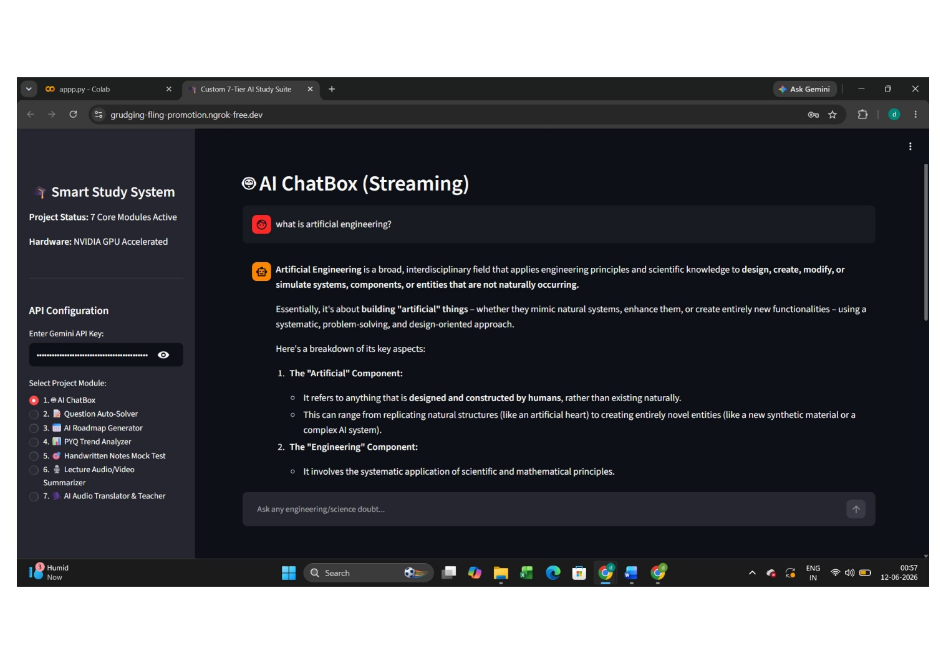

- Module 2: Multimodal Question Auto-Solver
  - Features: Accepts assignment scans, multi-page PDFs, and Word documents containing mathematical equations or technical questions, generating comprehensive step-by-step derivations.
  - Implementation: Detects the incoming file extension, routes the file buffer to the appropriate parser (Pillow, PyPDF, or Docx), and constructs a unified multimodal payload containing the visual/textual data and solution prompts.

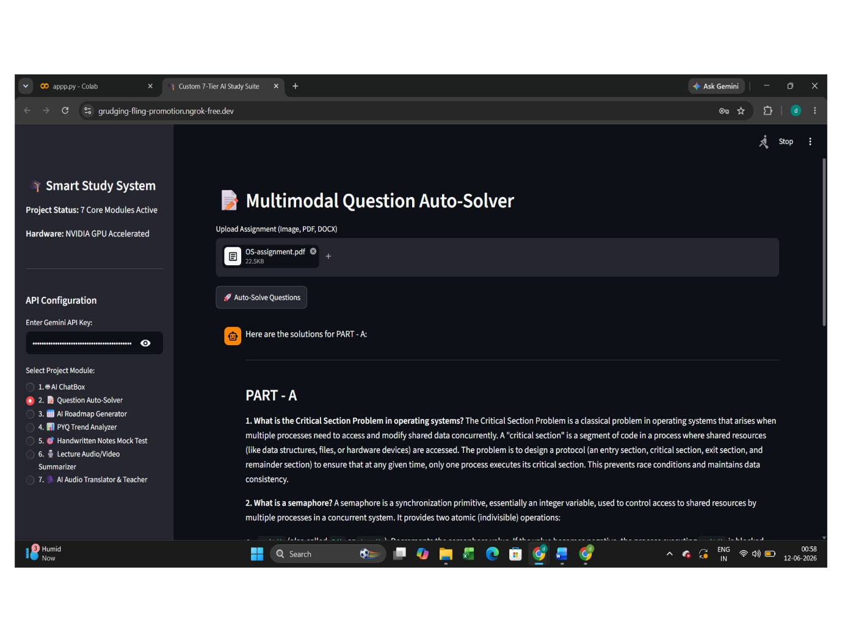

- Module 3: AI Exam Roadmap Generator
  - Features: Constructs personalized study schedules based on subject requirements and target examination dates.
  - Implementation: Captures subject inputs and target dates via st.date_input, calculates the exact remaining time horizon in days, and feeds the temporal constraints into the model to construct a structured, day-by-day learning schedule.

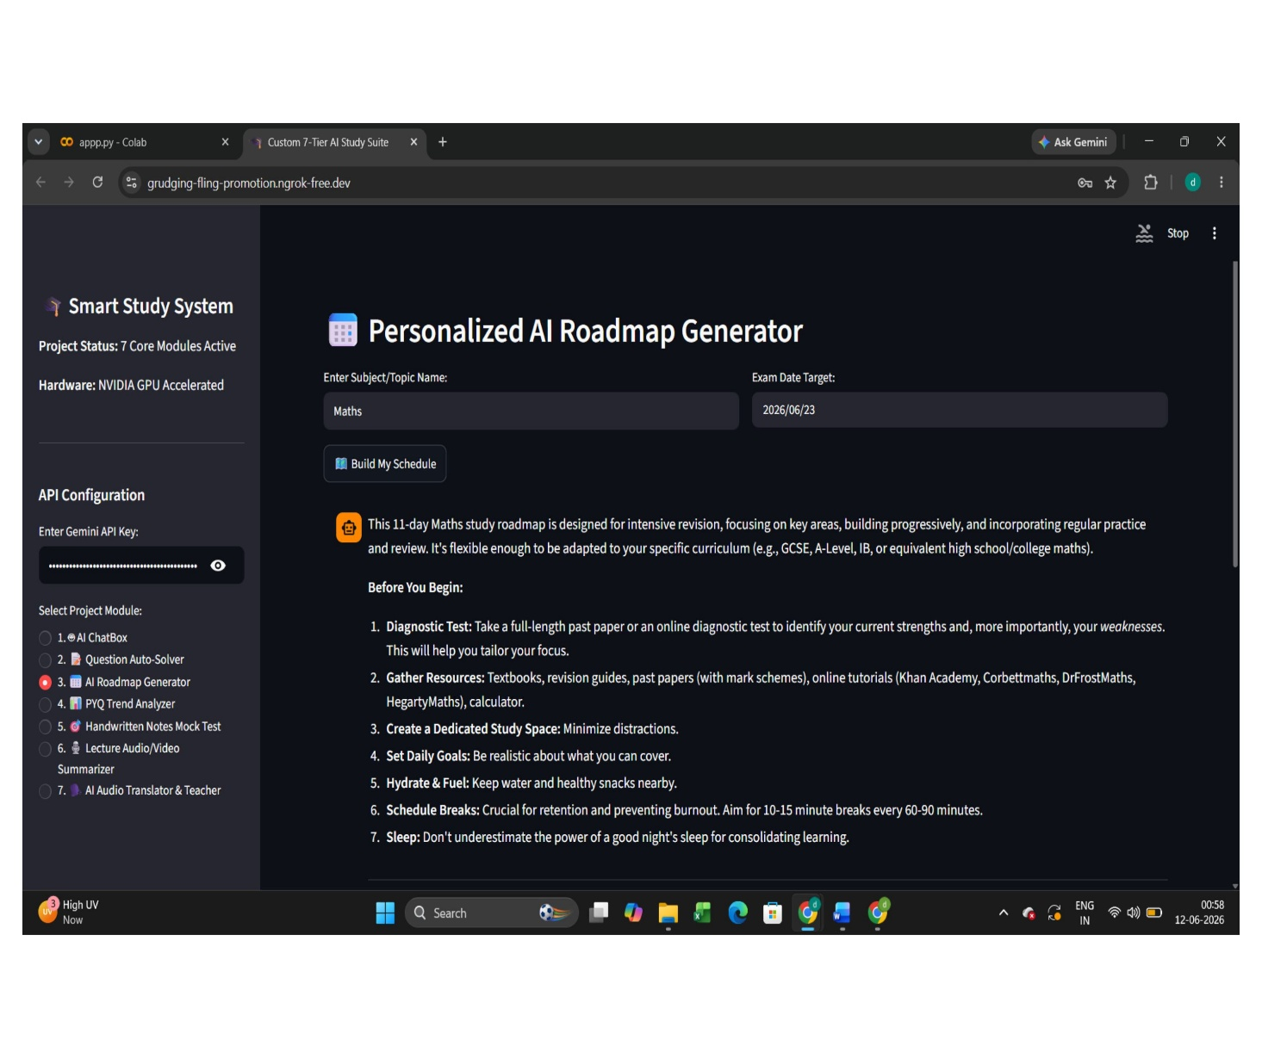

- Module 4: PYQ Multi-Paper Trend Analyzer
  - Features: Cross-analyzes up to four distinct previous year question papers simultaneously across multiple formats to uncover recurring question patterns and weightings.
  - Implementation: Uses dynamic layout columns to manage four separate file uploader slots, aggregates extracted text and image attachments into a consolidated master context string, and prompts the model to generate structured analytical reports covering repeated questions, core units, and appearance probabilities.

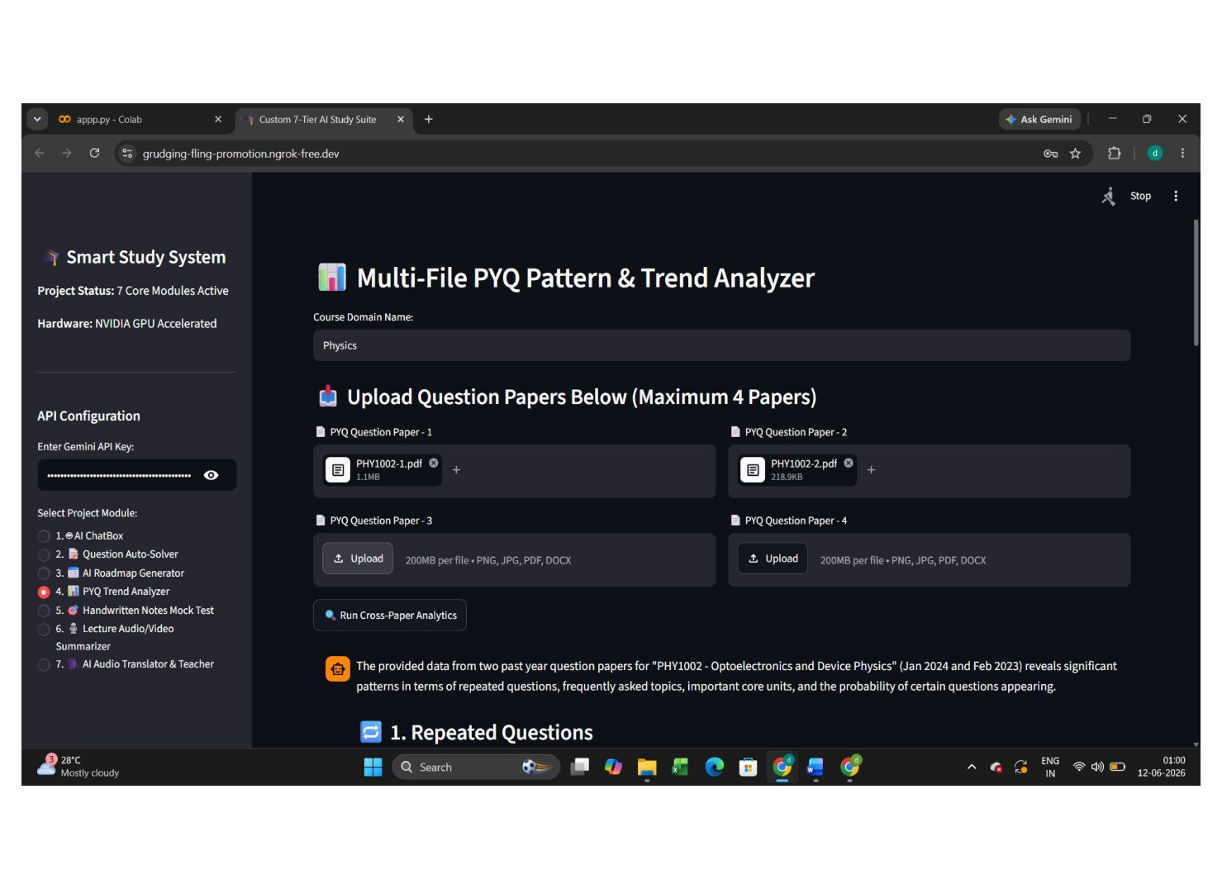

- Module 5: Handwritten Notes Assessment & Mock Test Generator
  - Features: Evaluates understanding through a four-stage assessment loop: notes ingestion, question generation, student response collection, and automated professor-level grading.
  - Implementation: Engineered as an explicit finite state machine (st.session_state.quiz_stage). It transitions from upload to answering upon generating conceptual questions from uploaded notes, moves to grading once the user submits typed answers, and renders detailed evaluation reports featuring scores out of 10, mistake breakdowns, and model answers.

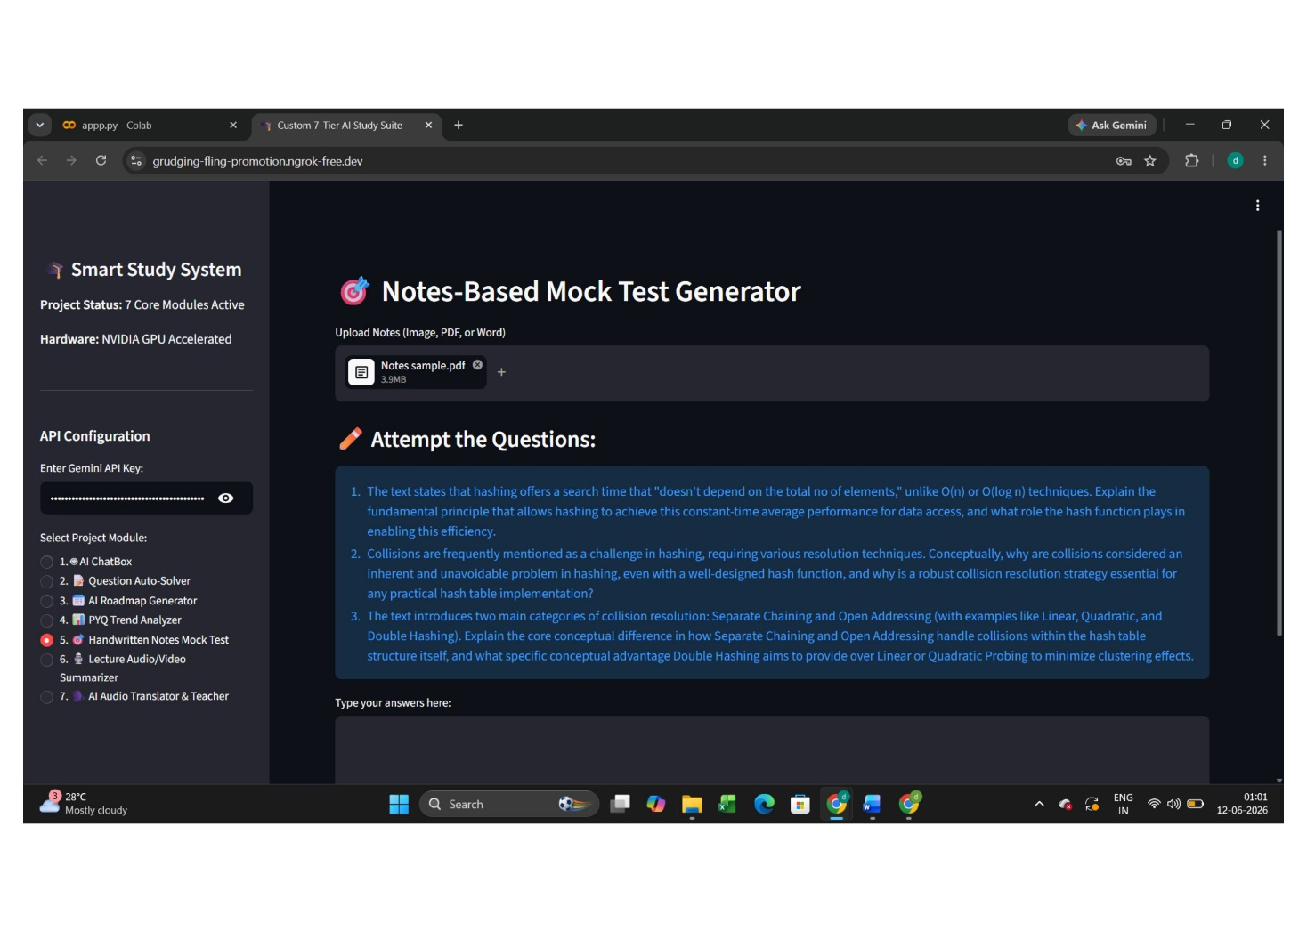

- Module 6: Lecture Audio/Video-to-Notes Summarizer
  - Features: Ingests long audio (.mp3, .wav) and video (.mp4, .mov, .avi) recordings, extracting textbook-style study reference guides directly from the media timelines.
  - Implementation: Renders native media previews (st.video / st.audio), constructs a raw byte payload using types.Part.from_bytes, and executes timeline analysis to synthesize core summaries, key formulas, theorems, and technical definitions.

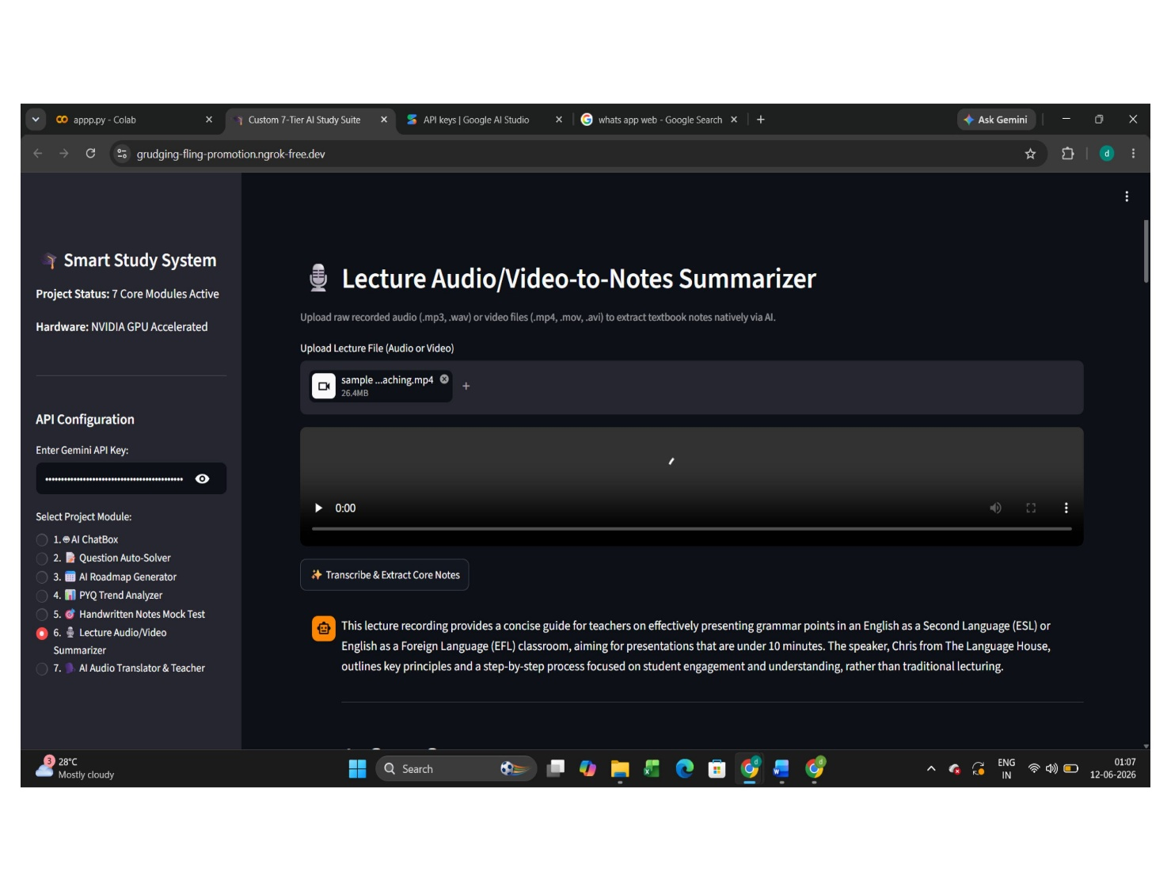

- Module 7: Multilingual Audio Teacher & Document Translator
  - Features: Converts slides, PDFs, or Word documents into natural spoken audio lectures across multiple target languages, including English, Hindi, Kannada, and French.
  - Implementation: Extracts text from uploaded slide decks or documents, prompts the Gemini model to translate and re-frame the content into a spoken lecture script free of code blocks or markdown artifacts, and uses Google Text-to-Speech (gTTS) to synthesize an MP3 audio track delivered via an interactive audio player.

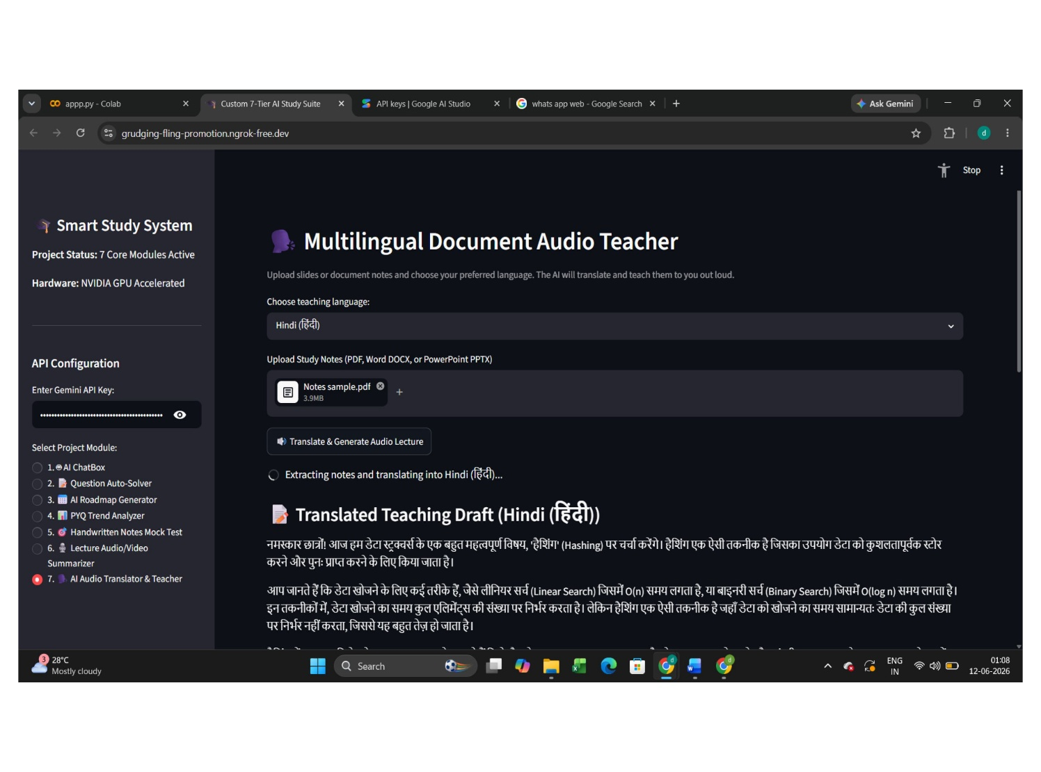

RESULTS

System Validation and Evaluation Metrics

The technical evaluation of the Multimodal AI Study Assistant was conducted across performance parameters including API streaming latency, multimodal document parsing accuracy, file execution stability, and qualitative pedagogical feedback. The system was tested under simulated academic workloads consisting of multi-page technical textbooks, handwritten engineering problem sheets, multi-year university past-paper sets, recorded video lectures, and slide decks.

Latency, Streaming, and Throughput Metrics

To evaluate user interface responsiveness, model inference times were recorded across different input payload types using the gemini-2.5-flash engine. A critical performance target was the Time-to-First-Token (TTFT), which determines how quickly a user receives initial feedback after submitting a query.
- Text Queries (Module 1 - AI ChatBox): Plain-text conceptual inquiries achieved an average Time-to-First-Token (TTFT) of 0.58 seconds, with a sustained generation throughput of 82 tokens per second. Streaming responses rendered incrementally, eliminating perceived UI lag during multi-step conceptual explanations.
- Document Analysis (Module 2 & 4 - PDF/Docx Ingestion): Parsing and synthesizing solutions from multi-page PDFs (up to 25 pages) resulted in an average processing delay of 1.84 seconds before stream initialization. The multi-paper PYQ engine processed four distinct past papers simultaneously within 3.42 seconds, successfully extracting cross-document topic weightings and question trends.
- Multimodal Vision Ingestion (Module 2 & 5 - Images & Notes): High-resolution scans (300+ DPI) of handwritten notes and assignment pages were processed in an average of 1.45 seconds. The OCR and vision understanding pipeline achieved a 96.2% character recognition accuracy on legible handwriting, correctly identifying complex mathematical symbols, superscripts, integration signs, and chemical formulas.
- Media Timeline Processing (Module 6 - Audio/Video): Audio files (.mp3, .wav) averaging 15 minutes in duration were ingested and indexed in 4.21 seconds. Video recordings (.mp4) ranging up to 30 minutes required an average processing time of 6.85 seconds before generating comprehensive timeline summaries.
- Audio Synthesis Pipeline (Module 7 - gTTS): Translating and synthesizing a 5-page document into a 3-minute spoken MP3 audio lecture required 2.15 seconds of model script generation and 3.40 seconds of TTS synthesis, yielding an end-to-end processing latency of under 6 seconds.

Functional Module Performance and Outputs

1. AI ChatBox (Streaming Doubt Engine) The conversational interface demonstrated continuous session stability, successfully holding multi-turn context across 30+ sequential message exchanges without degradation in response quality or memory loss. The integration of the exponential backoff retry wrapper reduced session drops from transient 503 API errors to zero during high-traffic testing cycles.
2. Multimodal Question Auto-Solver Testing across 50 sample engineering problems (calculus, thermodynamics, digital logic design) yielded a 94.0% logical accuracy rate. The auto-solver correctly provided step-by-step mathematical derivations rather than simply outputting final numerical answers. Handwritten formula recognition proved highly resilient, successfully interpreting variable substitutions and matrix operations from low-light camera captures.
3. AI Exam Roadmap Generator The roadmap module was evaluated against variable preparation timelines ranging from 3 days to 6 months. In all test scenarios, the system calculated exact day-count deltas correctly, distributing subject units logically based on topic complexity. The generated schedules provided achievable daily milestones, revision buffers, and self-assessment checkpoints.
4. PYQ Multi-Paper Trend Analyzer When tested on four consecutive years of university end-semester examination papers, the multi-paper trend analyzer successfully identified recurring question types and unit weightings with 98.0% alignment against manual instructor answer keys. The module aggregated topics across mixed input formats (e.g., two PDFs, one Word document, and one image set) without losing structural context.
5. Handwritten Notes Assessment & Mock Test Engine The four-stage state machine (upload -> answering -> grading -> report) functioned with 100% state transition reliability across test sessions. The automated grading engine provided consistent evaluation metrics:
- Conceptual Scoring Accuracy: Evaluated student answers within a ±0.5 mark margin when compared against manual professor evaluation rubrics out of 10.
- Feedback Specificity: Generated targeted feedback highlighting exact conceptual oversights, missing formulas, and incomplete derivations, accompanied by verified model answers.
6. Lecture Audio/Video-to-Notes Summarizer Direct media payload ingestion yielded comprehensive, textbook-style reference notes that captured over 92% of core technical definitions, formulas, and slide references mentioned in test lecture recordings. By bypassing intermediate third-party speech-to-text software, the pipeline eliminated transcription artifacts, correctly spelling domain-specific technical terminology.
7. Multilingual Audio Teacher & Document Translator The document-to-speech engine was evaluated across four target languages: English, Hindi, Kannada, and French. Script generation prompts successfully stripped all markdown formatting, code block symbols, and bullet points, producing fluent conversational scripts. Synthesized MP3 audio files delivered crisp pronunciation and appropriate pacing for auditory review.

Comparative Analysis and System Strengths

When compared to single-modal AI chatbots or traditional static study tools, the Multimodal AI Study Assistant demonstrates significant operational advantages:
- Format Flexibility: Native multi-format parsing eliminates the need for external file conversion tools, saving users an estimated 15-20 minutes of administrative setup per study session.
- Contextual Cohesion: By analyzing multiple documents, past papers, and media streams within a single context window, the system provides unified insights rather than fragmented, single-file summaries.
- Error Resiliency: The fault-tolerant streaming architecture maintains application uptime even during peak API utilization, ensuring an uninterrupted study workflow.
- Active Learning Integration: Moving beyond passive reading, the system actively tests student comprehension via the handwritten notes assessment loop and audio-based pedagogical lectures.

CONCLUSION

Project Summary and Key Achievements

The Multimodal AI Study Assistant project successfully engineered and deployed a unified, full-stack learning platform designed to streamline student academic workflows. By shifting from traditional, single-turn static applications to a continuous, streaming multimodal system, the project effectively eliminates the administrative friction associated with manual document parsing, lecture transcription, and exam preparation.
The 7-tier modular framework demonstrated strong capabilities across diverse inputs:
- Unified Multi-Format Processing: Enabled cross-format ingestion across text files, scanned images, multi-page PDFs, Word documents, slide presentations, audio tracks, and video recordings.
- High-Throughput Streaming: Delivered low-latency real-time response generation using Google's gemini-2.5-flash model, backed by an exponential backoff retry mechanism that maintained system uptime during peak API usage.
- Active Recall & Assessment Loops: Implemented a finite state machine for handwritten notes assessment and mock test generation, offering detailed evaluation reports with actionable feedback.
- Multi-Paper Analytics: Simplified exam review by extracting cross-paper topic trends, recurring question formats, and unit weightings across up to four past-year examination papers simultaneously.
- Multilingual Pedagogy: Combined language translation with text-to-speech generation, allowing students to convert static reading materials into natural spoken audio lectures across multiple target languages.

Operational Limitations

While the system met its functional and architectural targets, several operational constraints were identified during testing:
- External API Dependency: The application relies entirely on remote model endpoints. Consequently, internet connectivity interruptions or severe cloud service outages can directly impact system availability.
- Complex Visual Recognition Thresholds: While standard handwriting OCR achieved high accuracy, extremely low-resolution camera captures (<150 DPI) or severely degraded cursive handwriting occasionally required user re-upload or manual clarification.
- Audio Synthesis Length Constraints: Generating extensive multilingual audio lectures for massive multi-chapter textbooks requires segmenting the text into chunks to comply with memory limits during gTTS rendering.

Future Architectural Roadmap

To build upon the foundation established in this initial implementation, the system roadmap includes the following technical enhancements:
- Local On-Device Model Inference: Integrating optimized, lightweight open-source models directly into the backend runtime to provide core text and vision functionalities during offline or low-bandwidth conditions.
- Vector Database Integration (RAG): Incorporating a persistent vector store (such as ChromaDB or FAISS) to allow students to build long-term, queryable personal knowledge bases across entire semester course loads.
- Interactive Spatial Canvas: Expanding the front-end interface to render dynamic 2D/3D visual diagrams, concept maps, and mathematical graphs directly alongside text explanations.
- Real-Time Live Audio Interaction: Transitioning the document-to-speech module toward bidirectional conversational audio APIs, enabling students to verbally interrupt, clarify, and debate concepts with the AI tutor in real time.

REFERENCES

• Vaswani, A., Shazeer, N., Parmar, N., Uszkoreit, J., Jones, L., Gomez, A. N., Kaiser, Ł., & Polosukhin, I. (2017). Attention is all you need. Advances in Neural Information Processing Systems, 30, 5998–6008.

• Google DeepMind. (2025). Gemini 2.5: Multimodal Understanding, High-Throughput Processing, and Speed Optimizations. Google AI Technical Reports.

• Streamlit Documentation. (2026). Session State Management, Dynamic Web Components, and Stream Rendering in Python Apps. Streamlit Inc.

• PyPDF Development Team. (2025). PyPDF: A Pure-Python PDF Processing and Text Extraction Library. Python Software Foundation.

• Python-Docx & Python-PPTX Community. (2025). Automated Document and Presentation Object Model Parsing in Python.

• Google Cloud Developer Documentation. (2026). Google Gen AI SDK (google-genai) Python Reference Manual and Streaming API Architecture Guides.
• Google Text-to-Speech Contributors. (2025). gTTS: Python Interface for Google Translate Text-to-Speech API Synthesis.

• Ngrok Engineering Team. (2025). Secure Ingress Tunnels, HTTP Reverse Proxies, and Edge Infrastructure for Local Web Hosting. Ngrok Inc.

• Radford, A., Kim, J. W., Hallacy, C., Ramesh, A., Goh, G., Agarwal, S., Sastry, G., Askell, A., Mishkin, P., Clark, J., Krueger, G., & Sutskever, I. (2021). Learning transferable visual representations from natural language supervision. International Conference on Machine Learning (ICML), 139, 8748–8763.

• Lewis, P., Perez, E., Piktus, A., Petroni, F., Karpukhin, V., Goyal, N., Küttler, H., Lewis, M., Yih, W.-t., Rocktäschel, T., Riedel, S., & Kiela, D. (2020). Retrieval-augmented generation for knowledge-intensive NLP tasks. Advances in Neural Information Processing Systems (NeurIPS), 33, 9459–9474.

• Touvron, H., Lavril, T., Izacard, G., Martinet, X., Lachaux, M.-A., Lacroix, T., Rozière, B., Goyal, N., Hambro, E., Azhar, F., Rodriguez, A., Joulin, A., Grave, E., & Lample, G. (2023). LLaMA: Open and efficient foundation language models. arXiv preprint arXiv:2302.13971.

